Task 3: Platforms

Hacker Rank: 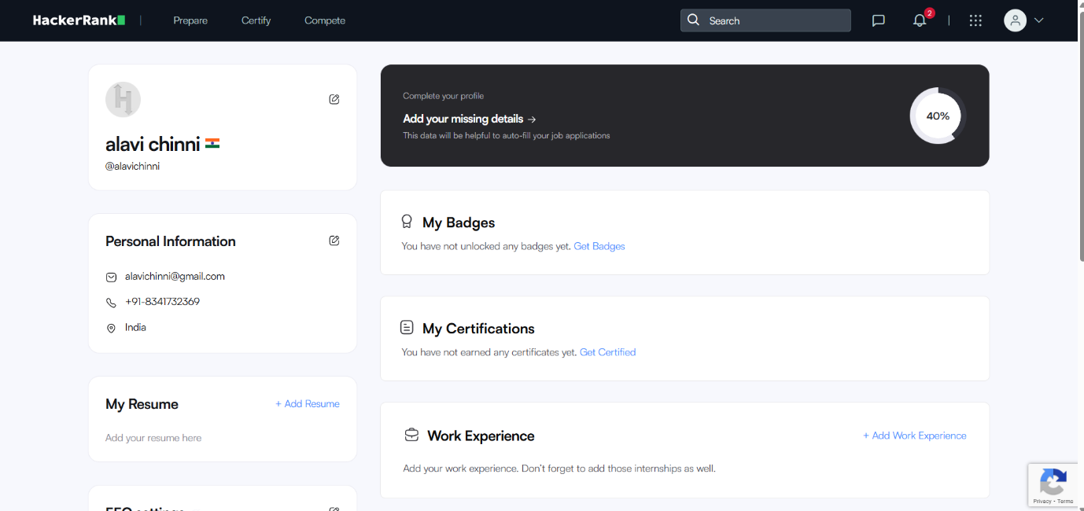

Google form: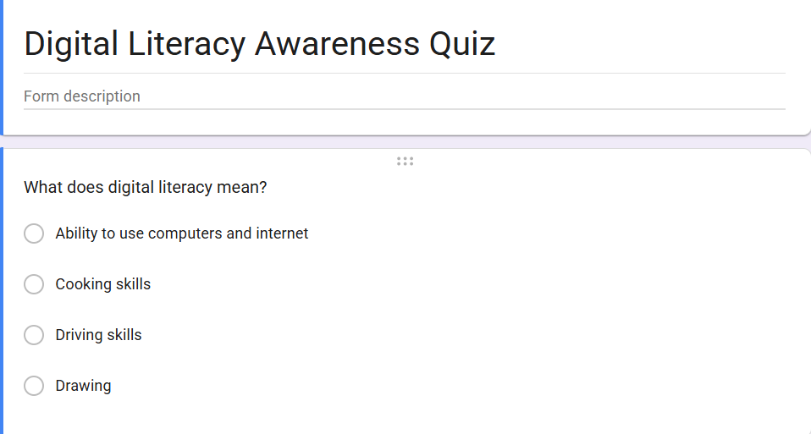
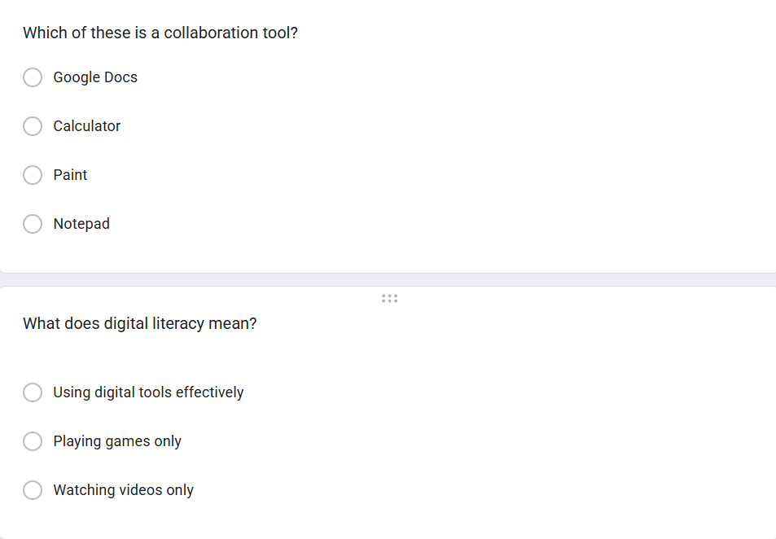
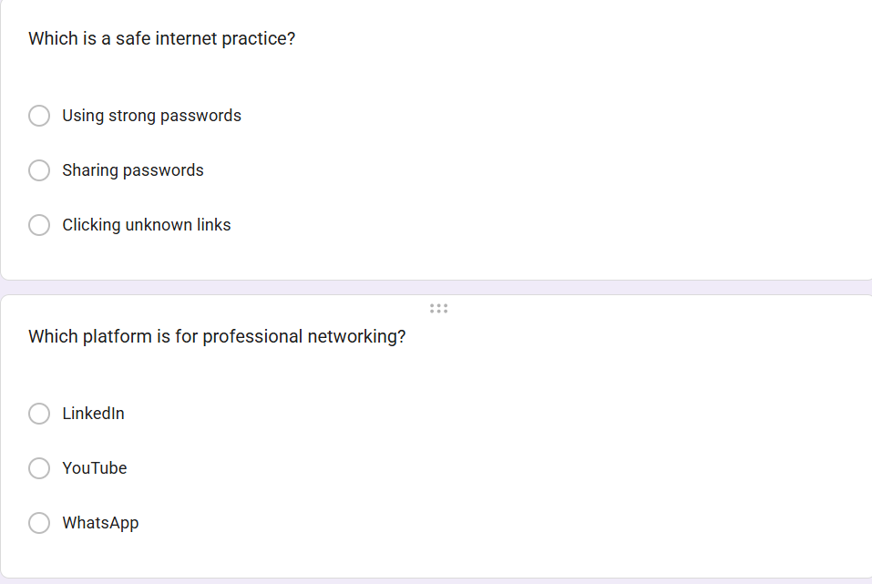

Response:
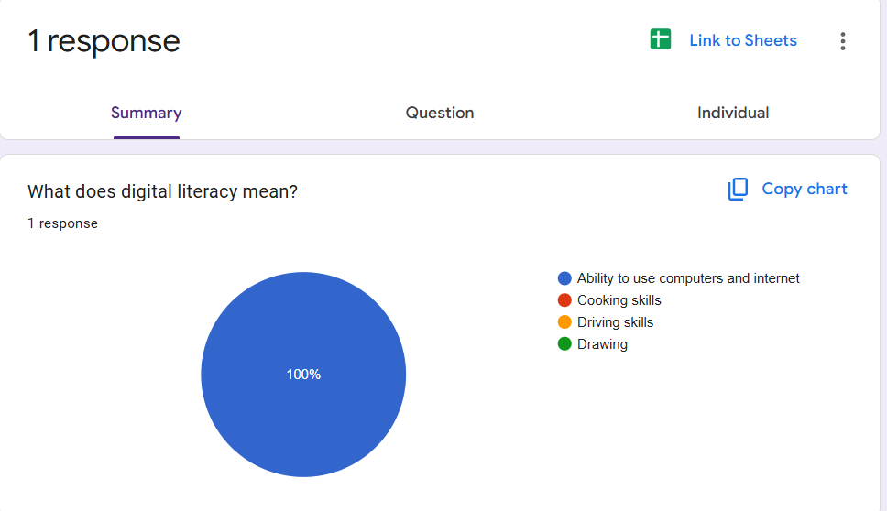
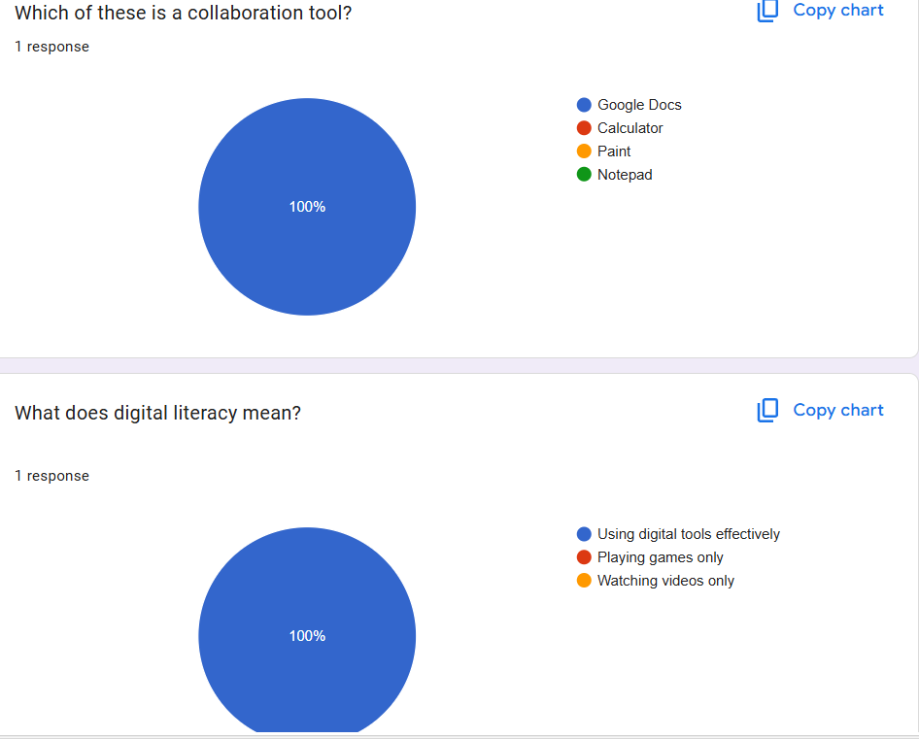
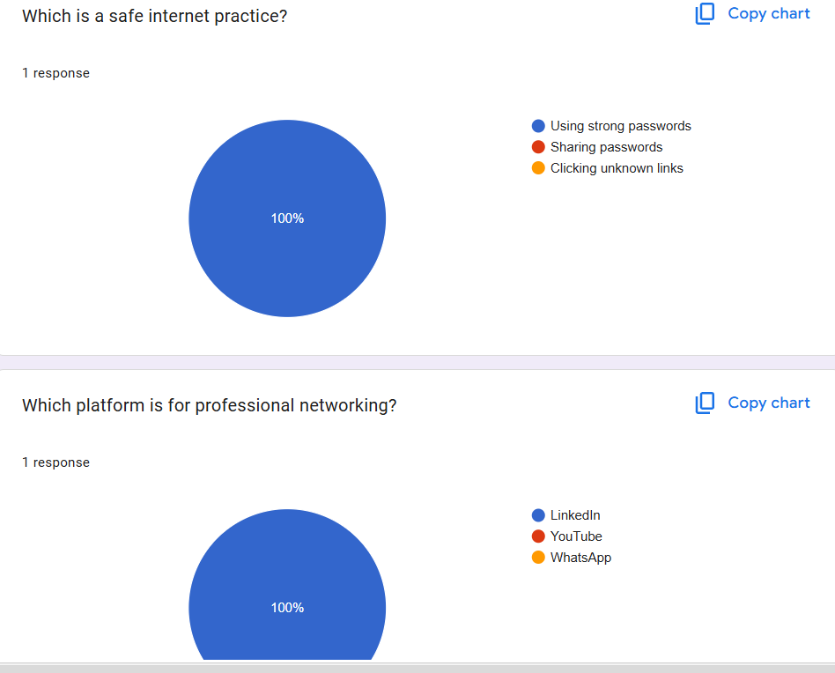
For Task 3, I used Hacker Rank and Google Forms to explore coding practice and collaboration tools. On Hacker Rank, I completed the beginner-level challenge “Solve Me First,” which helped me understand basic coding practice and online problem solving. It also introduced me to how coding platforms provide immediate feedback for learning.

I also created a Google Form titled “Digital Literacy Awareness Quiz” with five questions related to digital literacy topics. The form included multiple choice and short answer questions. I linked the form responses to Google Sheets to understand how digital tools support automatic response collection and organization.

These platforms will help me academically by improving programming practice, problem-solving ability, and collaboration skills. Hacker Rank supports coding improvement, while Google Forms and Google Sheets are useful for quizzes, surveys, and academic data collection.

